HERO WEC 2024 Electric Deployment Data Descriptions

Raw Data (TDMS, bag, and CSV Files)
Raw data from the 2024 HERO WEC electrical deployment was recorded and saved to multiple DAQs on the system. All RO and power electronics subsystem data was recorded and saved to the onshore MODAQ system in the form of TDMS files. Buoy data was transmitted to the onshore MODAQ and saved in the form of TDMS files, however intermittent connection issues resulted in brief interruptions in the data stream received onshore and the .bag files saved to the on-buoy MODAQ system were selected for use in data processing, as connection issues did not affect the data saved to this system. Anchor load cell data was saved to the submersible DAQ in the form of CSV files. It is important to note that due to this DAQ’s location near the seabed, its clock could not be synchronized using GPS like the other DAQs and an offset was applied to this time array during data processing to sync the air spring charge time with the on-buoy DAQ timestamps. The anchor load cell DAQ is powered by internal batteries and recorded data for the entire duration of the electrical configuration deployment. The onshore MODAQ and load cell DAQs automatically applied slopes and offsets to each data stream before saving data in engineering units. Slopes and offsets were applied to data saved to the buoy DAQ during data processing. The slopes and offsets applied to each data stream as well as sensor descriptions can be found in tables 2 through 6. All slopes and offsets were calculated using NREL’s sensor calibration procedures. Diagrams of sensor locations within each subsystem along with selected calibration sheets can be found in the appendix.
DAQ | Group | Sample Rate [Hz] | Data Format | GPS Time Sync
Buoy MODAQ | AIN | 10 | bag file | Yes
Onshore MODAQ | VoltageAI | 2000 | TDMS file | Yes
Onshore MODAQ | CurrentAI | 1000 | TDMS file | Yes
Onshore MODAQ | PowRaw | 5000 | TDMS file | Yes
Load Cell DAQ | LC | 10 | CSV file | No
Table 1: HERO WEC Sensor Groups
Sensor Name | Description | Units | Instrument Output | Slope | Offset
PRESS_OS_2002 | Air spring pressure | psi | 4-20 mA | 15.625 | -62.500
POS_OS_1001 | Encoder | degrees | 4-20 mA | 22.712 | -89.922
Table 2: AIN group sensors.
Sensor Name | Description | Units | Instrument Output | Slope | Offset
FLOW-ON-1001 | RO subsystem inlet flow | gpm | 4-20 mA | 1650 | -6.60
FLOW-ON-1002 | Clark pump inlet flow rate | gpm | 4-20 mA | 625 | -2.50
FLOW-ON-1003 | Brine discharge flow rate | gpm | 4-20 mA | 1650 | -6.60
FLOW-ON-1004 | Permeate flow rate | gpm | 4-20mA | 82.50 | -0.33
CND-ON-1001 | RO inlet conductivity | micro-Siemens | 4-20 mA | 6250000 | -25000
CND-ON-1002 | Permeate conductivity | micro-Siemens | 4-20 mA | 312500 | -1250
Table 3: CurrentAI group sensors.
Sensor Name | Description | Units | Instrument Output | Slope | Offset
PRESS-ON-1001 | RO subsystem inlet pressure | psi | 0-10 V | 15.000 | 0.000
PRESS-ON-1002 | Clark pump inlet pressure | psi | 0-10V | 10.000 | 0.000
PT-ON-2001 | Rectifier output voltage | V | 0-10 V | 71.397 | -0.025
PT-ON-2002 | Charge controller input voltage | V | 0-10 V | 30.002 | -0.077
PT-ON-2003 | Charge controller output voltage | V | 0-10 V | 10.005 | -0.024
PT-ON-2004 | Battery voltage | V | 0-10 V | 10.005 | -0.024
PT-ON-2005 | Pump controller voltage | V | 0-10 V | 10.005 | -0.018
PT-ON-2006 | Pump A voltage | V | 0-10 V | 10.003 | -0.016
PT-ON-2007 | Pump B voltage | V | 0-10 V | 10.001 | -0.013
CT-ON-2001 | Rectifier output current | A | 0-10 V | 8.000 | 0.000
CT-ON-2002 | Charge controller input current | A | 0-10 V | 7.999 | 0.000
CT-ON-2003 | Charge controller output current | A | 0-10 V | 8.000 | 0.000
CT-ON-2004 | Battery input current | A | 0-10 V | 8.000 | 0.000
CT-ON-2005 | Pump controller current | A | 0-10 V | 4.999 | -0.004
CT-ON-2006 | Pump A current | A | 0-10 V | 4.997 | -0.006
CT-ON-2007 | Pump B current | A | 0-10 V | 4.998 | -0.007
Table 4: VoltageAI group sensors.
Sensor Name | Description | Units | Instrument Output | Slope | Offset
LC-MOOR-1001 | Anchor load cell | lbf | mV/V | 4586.290 | 0.043
Table 5: Load cell DAQ group sensors.
Sensor Name | Description | Units | Instrument Output | Slope | Offset
PT-ON-1001 | Generator phase 1 voltage | V | 0-10 V | 71.43 | 0.00540
PT-ON-1002 | Generator phase 2 voltage | V | 0-10 V | 71.42 | 0.00893
PT-ON-1003 | Generator phase 3 voltage | V | 0-10 V | 71.43 | 0.00540
CT-ON-1001 | Generator phase 1 current | A | 0-10 V | 8.00 | 0
CT-ON-1002 | Generator phase 2 current | A | 0-10 V | 8.00 | 0
CT-ON-1003 | Generator phase 3 current | A | 0-10 V | 8.00 | 0
Table 6: PowRaw group sensors.
Processed Subsystem Array Data (Parquet Files)

Details of Products (columns) Added to Original Data

Quality Control (QC)
Data was processed to identify and correct any out of bounds values using a QC process developed by NREL. This process compared each individual value to the sensor’s measurement limits and identified all out of bounds values. A new qc_<original_channel_name> array was built for each raw data array to store these QC flag values. In these arrays, a value of zero indicates that the sensor’s reading was within bounds at a given timestamp, a value of 1 indicates that a data point was above the maximum value which the sensor can measure, while a value of 2 indicates that a data point was below the minimum value which a sensor can measure.
Value Added Products (VAP)
In this process, Value Added Products (VAPs) were produced to allow for thorough analysis of the data. VAPs in this data set are sorted into two categories, standard VAPs (arrays prefixed with vap_) are arrays where raw data was modified to become usable for calculations (such as applying phase shifts to the encoder data to remove discontinuities at zero crossings), and calculated VAPs (prefixed with calc_) are arrays where calculations were performed to provide data which could not be directly measured. Calculated VAPs are present only in the final output and summary data files.
Zero Crossing Fixes on POS-OS-1001
360-degree offsets were applied to portions of the encoder data to remove discontinuities at locations where the 0/360-degree mark on the encoder was crossed. This step was performed using an NREL developed script which identifies these events, checks for and removes anomalous data points recorded as the encoder outputs rapidly changes between the limits of its range, and then uses MATLAB’s unwrap function to shift the phase angles of the data set resulting in a continuous encoder position profile. This array is saved as vap_POS_OS_1001_UW. The unwrapped encoder data was then smoothed using a Savgol filter so that the encoder velocity could be calculated later, and this array is saved as vap_POS_OS_1001_UW_S.
Synchronization of LC-MOOR-1001 with WEC and On-Shore DAQs
Fixing the zero crossings on POS-OS-1001 enabled the comparison of calc_Winch_V and LC-MOOR-1001 to identify the timestamps of the airspring charge time and cable breaking on both the load cell DAQ and onbuoy DAQ. The load cell DAQ clock was then offset to align the air spring charge time and cable break time stamps with the timestamps of these events recorded by the GPS synchronized on buoy MODAQ system. During this deployment, it was found that the mooring DAQ clock was 15.152 seconds behind the on buoy DAQ clock and no noticeable drift occurred over the time frame of the deployment. Following this data processing, the data from each sensor along with its qc array and processed data (when applicable) was put into an individual parquet file.
Alignment and resampling of measurements with different sampling rates
Next, these files were grouped to build a parquet file of data for each subsystem. In this step, the anchor load cell data was resampled to the on buoy DAQ timestamps and data from PRESS-ON-1001 and PRESS-ON-1002 was down sampled to match the timestamps of the rest of the RO subsystem sensors on the CurrentAI group.

Subsystem | Abbreviation | Sample Rate [Hz] | Arrays
WEC | WEC | 10 | LC-MOOR-1001 (Resampled)  POS-OS-1001  vap_POS_OS_1001_UW  vap_POS_OS_1001_UW_S  PRESS-OS-2002  WEC_Timestamp_NS  WEC_Datetime
WEC Generator | Gen | 5000 | PT-ON-1001  PT-ON-1002  PT-ON-1003  CT-ON-1001  CT-ON-1002  CT-ON-1003  Gen_Timestamp_NS  Gen_Datetime
Onshore Power Electronics | PE | 2000 | PT-ON-2001  PT-ON-2002  PT-ON-2003  PT-ON-2004  PT-ON-2005  PT-ON-2006  PT-ON-2007  CT-ON-2001  CT-ON-2002  CT-ON-2003  CT-ON-2004  CT-ON-2005  CT-ON-2006  CT-ON-2007  PE_Timestamp_NS  PE_Datetime
Reverse Osmosis System | RO | 1000 | FLOW-ON-1001  FLOW-ON-1002  FLOW-ON-1003  FLOW-ON-1004  PRESS-ON-1001 (Down Sampled)  PRESS-ON-1002 (Down Sampled)  CND-ON-1001  CND-ON-1002
Table 6: Electric configuration subsystems.
Once data from each group was resampled to common timestamps, Python was then used to perform instantaneous power calculations at various points in the system along with additional calculations useful for understanding system performance. A description of each calculated array can be found in table 7. Velocity calculations were performed using Python’s np.gradient function to calculate an instantaneous velocity array from position data using numerical differentiation. This function primarily uses the central difference method; however, the forward difference and backwards difference methods are used at the beginning and end of the array to avoid the loss of data points in the velocity array.
Name | Subsystem | Description | Units
calc_POS_OS_1001_UW_S_V | WEC | Encoder velocity calculated using pyhton’s np.gradient function. | rpm
calc_Winch_V | WEC | Winch velocity. Encoder velocity multiplied by 4.5 (first stage spring return ratio) | rpm
calc_Gearbox_V | WEC | Gearbox output shaft velocity. Calc_V_Winch multiplied by 11.28 (gearbox ratio) | rpm
calc_P_abs | WEC | Instantaneous absorbed power (Calc_V_Winch * LC_ST_1001). This calculation is not performed after data collection on the load cell DAQ stops. | kW
calc_P_WEC_Electric_Out | Gen | Instantaneous AC power input to rectifier. WEC AC power output after losses due to transmission across subsea cable. | kW
calc_P_Electric_1 | PE | Instantaneous DC power output of rectifier | kW
calc_P_Electric_2 | PE | Instantaneous DC power input to charge controller | kW
calc_P_Electric_3 | PE | Instantaneous DC power output of charge controller | kW
calc_P_Electric_4 | PE | Instantaneous DC power input to batteries | kW
calc_P_Electric_5 | PE | Instantaneous DC power input to pump controller | kW
calc_P_Electric_P1 | PE | Instantaneous DC power input to submersible pump #1 | kW
calc_P_Electric_P2 | PE | Instantaneous DC power input to submersible pump #2 | kW
calc_Eta_CC_I | PE | Instantaneous charge controller efficiency | kW
calc_Filter_DP | RO | Pressure differential across RO pre-filter | psi
calc_ACC_Flow | RO | Flow rate into onshore accumulators | Gpm
calc_P_Hydraulic_2 | RO | Hydraulic power at RO system inlet | kW
calc_P_Hydraulic_3 | RO | Hydraulic power at Clark pump inlet | kW
calc_Recovery_Ratio | RO | RO recovery ratio during test | -
Table 7: Calculated arrays.
After performing these calculations, the common timestamp data was then broken into 30-minute duration files. These files start at each hour and 30 minutes after each hour to align with the data contained in CDIP buoy files which will be used to create test data summary files. Each of these files contains data from all sensors within a subsystem as well as all calculations relevant to that subsystem performed on the same set of timestamps. These files were saved in parquet file format and can be found in the <subsystem> Data Parquet files in MHKDR Submission 551.
Half Hour Summary and Resource Data (Parquet Files)
A separate Python script was then utilized to perform summary calculations on each half hour data set and output an additional parquet file summarizing device performance during each half hour of operation. These calculations include data points useful for technoeconomic analysis of the device and for understanding long term operation of coastal WECs. A complete list of summary data contained in these files can be found in table 8.
Name | Description | Units
Calc_P_abs_AVG | Calculated average absorbed power | kW
Calc_Work_Electrical | Total electrical work done by generator during 30-minute interval | kJ
Calc_P_WEC_Electric_Out_AVG | Average AC power input to rectifier during 30-minute interval | kW
Calc_P_Electric_1_AVG | Average rectifier DC power output during 30-minute interval | kW
Calc_P_Electric_2_AVG | Average DC power input to charge controller during 30-minute interval | kW
Calc_P_Electric_3_AVG | Average DC power output from charge controller during 30-minute interval | kW
Calc_P_Electric_4_AVG | Average DC power input to batteries during 30-minute interval | kW
Calc_P_Electric_5_AVG | Average DC power input to pump controller during 30-minute interval | kW
Calc_P_Electric_P1_AVG | Average DC power input to submersible pump #1 during 30-minute interval | kW
Calc_P_Electric_P2_AVG | Average DC power input to submersible pump #2 during 30-minute interval | kW
Calc_P_Hydraulic_2_AVG | Calculated average hydraulic power at RO system inlet | kW
Calc_P_Hydraulic_3_AVG | Calculated average hydraulic power at Clark pump | kW
Calc_Q_Feed_AVG | Average flow rate of water received at RO subsystem | gpm
Calc_Q_Clark_Pump_AVG | Average flow rate at Clark pump | gpm
Calc_Q_Brine_AVG | Average flow rate of brine discharge | gpm
Calc_Q_Permeate_AVG | Average permeate flow rate | gpm
Calc_Eta_WEC | Calculated WEC efficiency (from winch to rectifier input) | %
Calc_Eta_Overall | Calculated system efficiency (from winch to Clark pump) | %
Calc_Eta_CC | Calculated charge controller efficiency | %
Calc_Eta_Rectifier | Calculated rectifier efficiency | %
Calc_Volume_RO | Total volume of water received at RO subsystem | gallons
Calc_Volume_Clark_Pump | Total volume of water received at Clark pump | gallons
Calc_Volume_Permeate | Total volume of permeate produced | gallons
Calc_Volume_Brine | Total volume of brine discharged | gallons
Calc_Tension_AVG | Average anchor line tension | lbf
Calc_Tension_Min | Minimum anchor line tension | lbf
Calc_Tension_Max | Maximum anchor line tension | lbf
Table 8: Summary data set values.
Nearby ocean observing buoys and weather stations were selected to provide wave resource insight during the HERO WEC deployment. Data from CDIP 243 (NDBC 44086) and CDIP 433 (NDBC 44100) during the timeframe of the HERO WEC deployment is provided with the HERO WEC data. These buoys are Waverider type buoys and are located significantly further offshore than the HERO WEC deployment location in 20-25 m water depth. Due to the different locations and water depths of the observing buoys relative to the HERO WEC, the data from these buoys should only be used as a reference of the sea states near the HERO WEC. The shallow water waves which the HERO WEC operates in are expected to have different heights, periods, and power than the waves measured by the wave rider buoy. Data from this buoy is included only to identify general trends in the sea state and should not be used for a performance analysis of the HERO WEC in individual sea states. Wind and atmospheric data recorded by the NDBC ORIN7 station located at the Oregon Inlet Marina is also provided. A total of seven environmental data files are available consisting of one data file for the ORIN7 station, and three data files for each ocean observing buoy. Of these three files, two are raw data files, one published by NDBC, and one published by CDIP, while the third file contains wave information calculated from the CDIP wave spectral density data using MHKiT. This file contains important information such as the energy period and wave power flux.
MATLAB Workspaces (Processed Array, Summary Data, and Resource Information)
A MATLAB script was then used to convert the 30-minute parquet files, summary statistics file, and wave resource files into workspaces. One workspace per subsystem is available for each half hour of the test. The MATLAB summary data file contains one row per half hour interval and is intended for use in long term analyses of wave powered desalination. Wave resource information is contained within this workspace. The processed MATLAB Workspaces are accompanied by a data viewer script allowing the user to easily plot all array data over a specified timespan within the selected 30-minute interval. To use the MATLAB data viewer script, the directory variable must be set to the location of the folder containing all downloaded workspaces and the start time variable must be set to the start of the 30-minute file to be plotted. This value is entered in UTC 24 hour date string format (‘DD-MMM-YYYY hh:mm:ss’) with either 00 or 30 entered for minutes. The deployment events table in appendix B can be used to identify timespans of interest for plotting. Subsystems to be omitted from plotting can be selected by changing the values of Input.<Subsystem> from ‘YES’ to ‘NO’. The script contains two options for plotting timespans, the “default” option plots the entire 30-minute interval, and the “custom” option can be used to plot data over a user specified timespan within the selected 30-minute interval. These options can be selected by changing the value of the “Visualization.Range” variable. When using the “custom” option, the variables “Visualization.Start” and “Visualization.End” must be manually set to the desired start and end times in UTC 24-hour date string format. Once run, this script produces all applicable plots.
Appendix A: Locations of Sensors within HERO WEC Subsystems

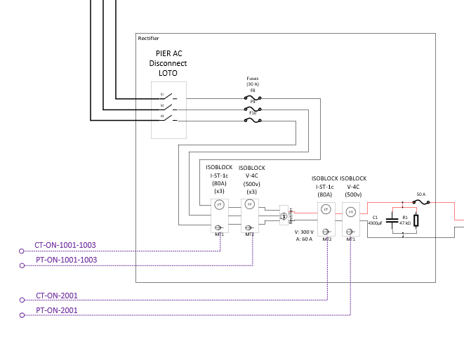
Figure 1: Location of PT and CT sensors used to measure 3 phase AC electricity from generator and DC electricity after rectifier. All components in this diagram before the rectifier are part of the generator subsystem, while the rectifier and all DC components are part of the onshore power electronics subsystem.
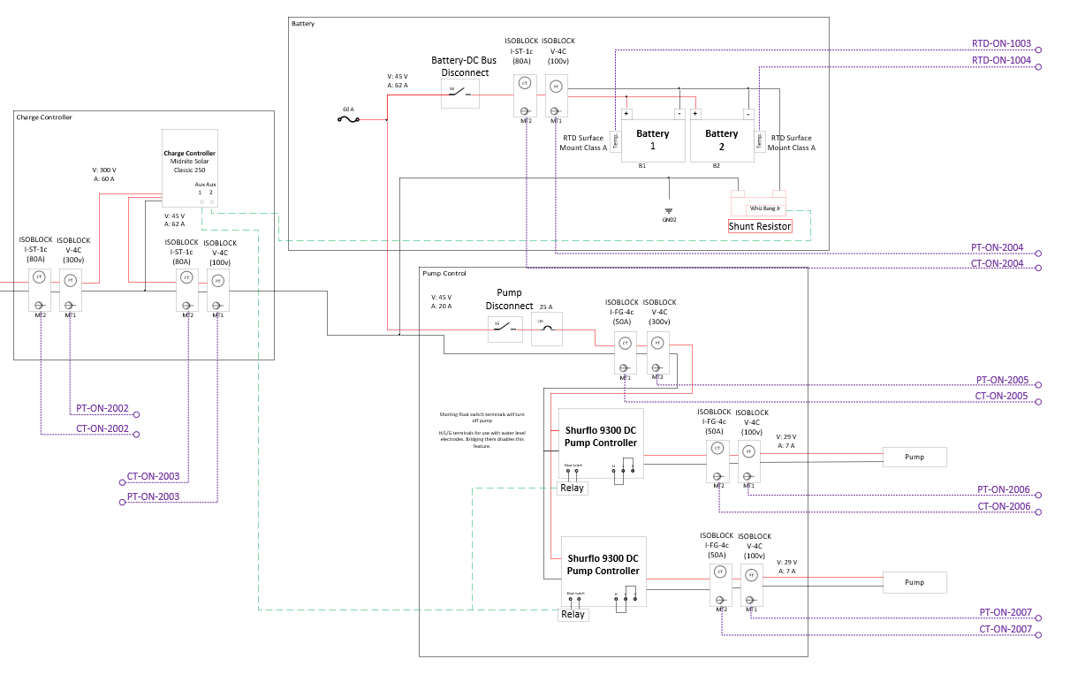
Figure 2: Location of PT and CT sensors after charge controller input. All components in this diagram are part of the onshore power electronics subsystem.
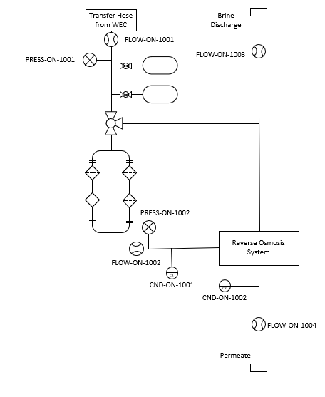
Figure 3: Location of RO subsystem sensors.

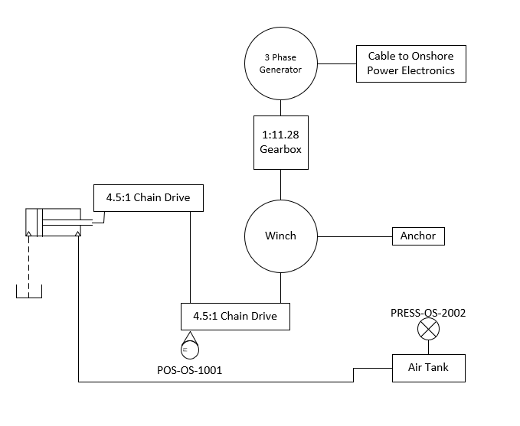
Figure 4: Location of WEC subsystem sensors.

Appendix B: HERO WEC Electrical Deployment Events
Event | UTC Time Stamp | Unix Timestamp [seconds]
Air spring charged | Thu Apr 18 2024 16:42:47 GMT | 1713458567.04
Batteries turned on | Thu Apr 18 2024 16:23:00 GMT | 1713457380.6
WEC generator connected to onshore power electronics | Thu Apr 18 2024 16:42:47 GMT | 1713458567
Batteries reach full charge | Fri Apr 19 2024 05:29:23 GMT | 1713504563
First end stop event | Fri Apr 19 2024 07:06:26 GMT | 1713510386
Cable breaks | Fri Apr 19 2024 07:51:32 GMT | 1713513092.36
Table 9: Timestamps of important events during the 2024 HERO WEC electric configuration deployment.

Appendix C: Sensor Calibration Sheets
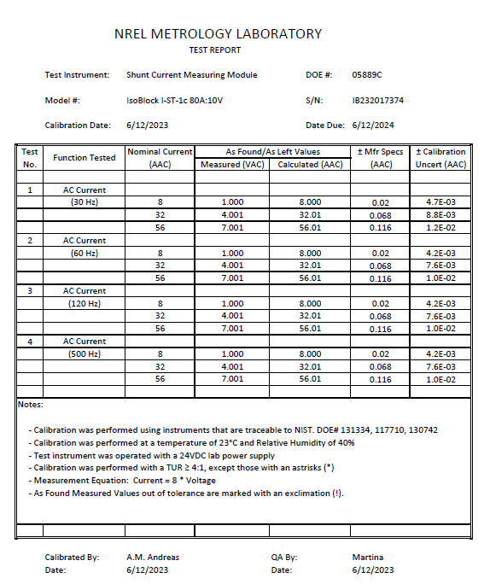
Figure 5: NREL calibration sheet for AC current transducer used to measure generator output current.
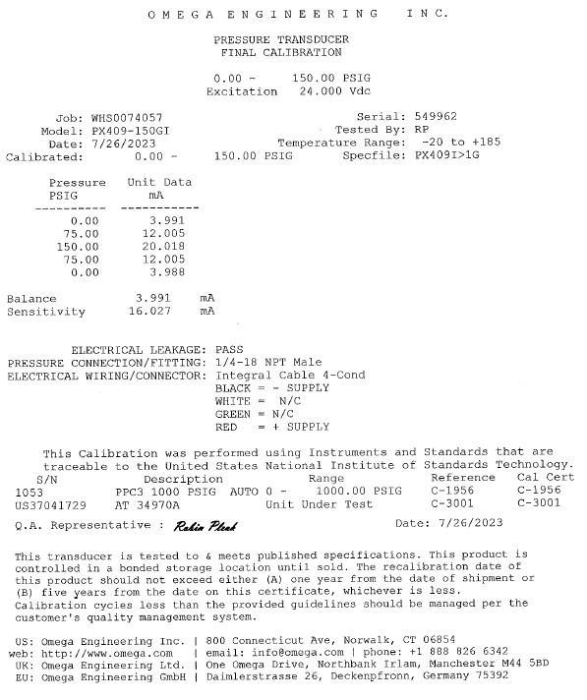
Figure 6: Manufacturer calibration sheet for HERO WEC pressure transducer.

